OSI MODEL IN COMPUTER NETWORKS:

* OSI stands for **Open System Interconnection** is a reference model that describes how information from a [software](https://www.javatpoint.com/software) application in one [computer](https://www.javatpoint.com/what-is-computer) moves through a physical medium to the software application in another computer.
* In plain English, the OSI provides a standard for different computer systems to be able to communicate with each other.
* OSI consists of seven layers, and each layer performs a particular network function.
* OSI model was developed by the International Organization for Standardization (ISO) in 1984, and it is now considered as an architectural model for the inter-computer communications.
* OSI model divides the whole task into seven smaller and manageable tasks. Each layer is assigned a particular task.
* Each layer is self-contained, so that task assigned to each layer can be performed independently.

Characteristics of OSI Model:

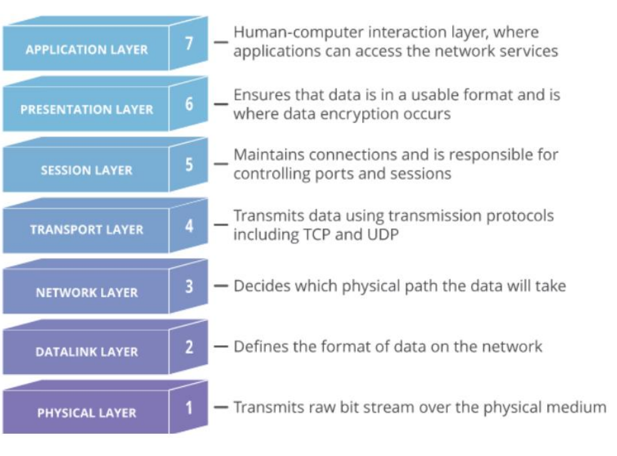

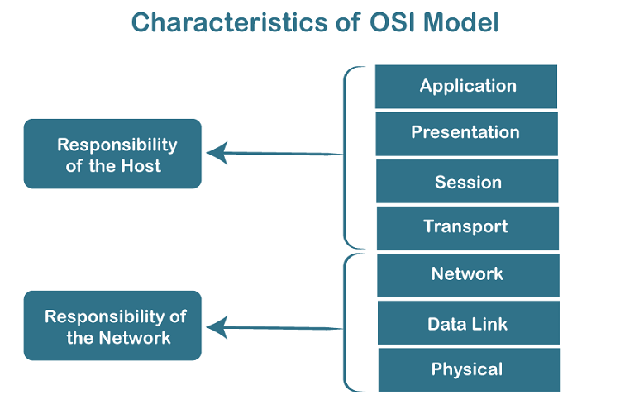

* The OSI model is divided into two layers: upper layers and lower layers.
* The upper layer of the OSI model mainly deals with the application related issues, and they are implemented only in the software. The application layer is closest to the end user. Both the end user and the application layer interact with the software applications. An upper layer refers to the layer just above another layer.
* The lower layer of the OSI model deals with the data transport issues. The data link layer and the physical layer are implemented in hardware and software. The physical layer is the lowest layer of the OSI model and is closest to the physical medium. The physical layer is mainly responsible for placing the information on the physical medium.

7 Layers of OSI Model

There are the seven OSI layers. Each layer has different functions. A list of seven layers are given below:

1. Physical Layer
2. Data-Link Layer
3. Network Layer
4. Transport Layer
5. Session Layer
6. Presentation Layer
7. Application Layer

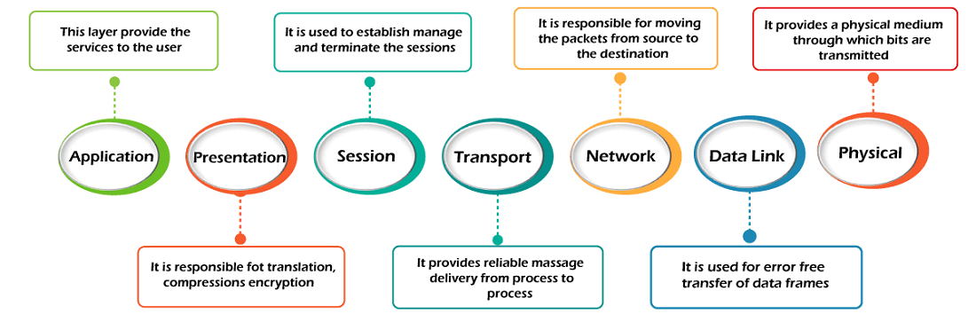

1.pysical layer :

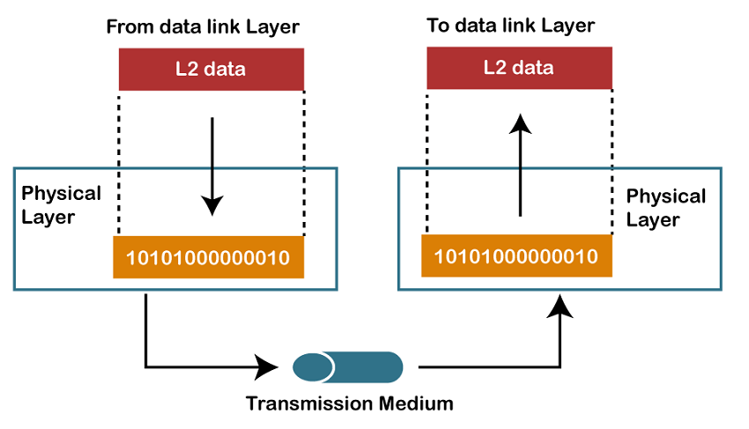

Functions of a Physical layer:

* **Line Configuration:** It defines the way how two or more devices can be connected physically.
* [**Data Transmission**](https://www.javatpoint.com/computer-network-transmission-modes)**:** It defines the transmission mode whether it is simplex, half-duplex or full-duplex mode between the two devices on the network.
* [**Topology**](https://www.javatpoint.com/computer-network-topologies)**:** It defines the way how network devices are arranged.
* **Signals:** It determines the type of the signal used for transmitting the information.
* This layer includes the physical equipment involved in the data transfer, such as the cables and switches.
* This is also the layer where the data gets converted into a bit stream, which is a string of 1s and 0s.
* The physical layer of both devices must also agree on a signal convention so that the 1s can be distinguished from the 0s on both devices.

2.DATA LINK LAYER :

* The data link layer is very similar to the network layer, except the data link layer facilitates data transfer between two devices on the SAME network.
* The data link layer takes packets from the network layer and breaks them into smaller pieces called frames.
* Like the network layer, the data link layer is also responsible for flow control and error control in intra-network communication (The transport layer only does flow control and error control for inter-network communications).
* 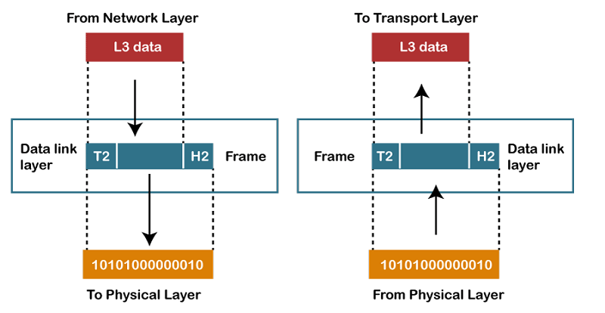

Functions of the Data-link layer

* **Framing:** The data link layer translates the physical's raw bit stream into packets known as Frames. The Data link layer adds the header and trailer to the frame. The header which is added to the frame contains the hardware destination and source address.
* **Physical Addressing:** The Data link layer adds a header to the frame that contains a destination address. The frame is transmitted to the destination address mentioned in the header.
* **Flow Control:** Flow control is the main functionality of the Data-link layer. It is the technique through which the constant data rate is maintained on both the sides so that no data get corrupted. It ensures that the transmitting station such as a server with higher processing speed does not exceed the receiving station, with lower processing speed.
* **Error Control:** Error control is achieved by adding a calculated value CRC (Cyclic Redundancy Check) that is placed to the Data link layer's trailer which is added to the message frame before it is sent to the physical layer. If any error seems to occur, then the receiver sends the acknowledgment for the retransmission of the corrupted frames.
* **Access Control:** When two or more devices are connected to the same communication channel, then the data link layer protocols are used to determine which device has control over the link at a given time.

## 3.Network Layer :

## OSI Model

* It is a layer 3 that manages device addressing, tracks the location of devices on the network.
* It determines the best path to move data from source to the destination based on the network conditions, the priority of service, and other factors.
* The Data link layer is responsible for routing and forwarding the packets.
* Routers are the layer 3 devices, they are specified in this layer and used to provide the routing services within an internetwork.
* The protocols used to route the network traffic are known as Network layer protocols. Examples of protocols are IP and Ipv6.

Functions of Network Layer:

* **Internetworking:** An internetworking is the main responsibility of the network layer. It provides a logical connection between different devices.
* [**Addressing**](https://www.javatpoint.com/network-addressing)**:** A Network layer adds the source and destination address to the header of the frame. Addressing is used to identify the device on the internet.
* [**Routing**](https://www.javatpoint.com/computer-network-routing)**:** Routing is the major component of the network layer, and it determines the best optimal path out of the multiple paths from source to the destination.
* **Packetizing:** A Network Layer receives the packets from the upper layer and converts them into packets. This process is known as Packetizing. It is achieved by internet protocol (IP).
* The network layer is responsible for facilitating data transfer between two different networks. If the two devices communicating are on the same network, then the network layer is unnecessary. The network layer breaks up segments from the transport layer into smaller units, called packets, on the sender’s device, and reassembles these packets on the receiving device. The network layer also finds the best physical path for the data to reach its destination; this is known as routing.

4.Transport Layer

* The Transport layer is a Layer 4 ensures that messages are transmitted in the order in which they are sent and there is no duplication of data.
* The main responsibility of the transport layer is to transfer the data completely.
* It receives the data from the upper layer and converts them into smaller units known as segments.
* This layer can be termed as an end-to-end layer as it provides a point-to-point connection between source and destination to deliver the data reliably.

**The two protocols used in this layer are:**

* **Transmission Control Protocol**
  + It is a standard protocol that allows the systems to communicate over the internet.
  + It establishes and maintains a connection between hosts.
  + When data is sent over the TCP connection, then the TCP protocol divides the data into smaller units known as segments. Each segment travels over the internet using multiple routes, and they arrive in different orders at the destination. The transmission control protocol reorders the packets in the correct order at the receiving end.
* **User Datagram Protocol**
  + User Datagram Protocol is a transport layer protocol.
  + It is an unreliable transport protocol as in this case receiver does not send any acknowledgment when the packet is received, the sender does not wait for any acknowledgment. Therefore, this makes a protocol unreliable.
  + 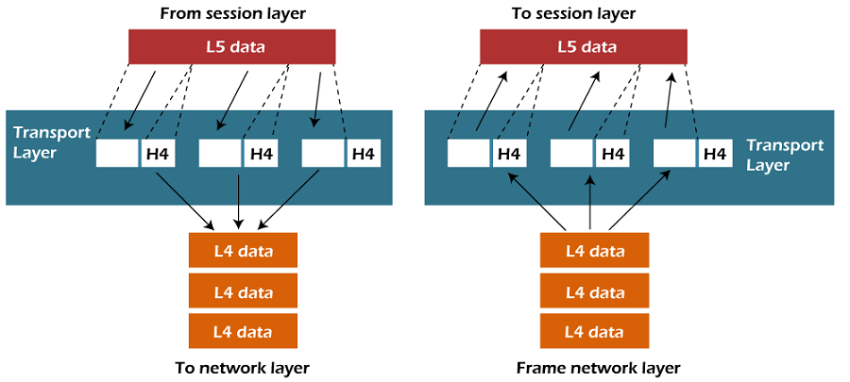

Functions of Transport Layer:

* **Service-point addressing:** Computers run several programs simultaneously due to this reason, the transmission of data from source to the destination not only from one computer to another computer but also from one process to another process. The transport layer adds the header that contains the address known as a service-point address or port address. The responsibility of the network layer is to transmit the data from one computer to another computer and the responsibility of the transport layer is to transmit the message to the correct process.
* **Segmentation and reassembly:** When the transport layer receives the message from the upper layer, it divides the message into multiple segments, and each segment is assigned with a sequence number that uniquely identifies each segment. When the message has arrived at the destination, then the transport layer reassembles the message based on their sequence numbers.
* **Connection control:** Transport layer provides two services Connection-oriented service and connectionless service. A connectionless service treats each segment as an individual packet, and they all travel in different routes to reach the destination. A connection-oriented service makes a connection with the transport layer at the destination machine before delivering the packets. In connection-oriented service, all the packets travel in the single route.
* **Flow control:** The transport layer also responsible for flow control but it is performed end-to-end rather than across a single link.
* **Error control:** The transport layer is also responsible for Error control. Error control is performed end-to-end rather than across the single link. The sender transport layer ensures that message reach at the destination without any error.

## 5.Session Layer :

## OSI Model

* It is a layer 3 in the OSI model.
* The Session layer is used to establish, maintain and synchronizes the interaction between communicating devices.

Functions of Session layer:

* **Dialog control:** Session layer acts as a dialog controller that creates a dialog between two processes or we can say that it allows the communication between two processes which can be either half-duplex or full-duplex.
* **Synchronization:** Session layer adds some checkpoints when transmitting the data in a sequence. If some error occurs in the middle of the transmission of data, then the transmission will take place again from the checkpoint. This process is known as Synchronization and recovery.

**6.** PRESENTATION LAYER :

* A Presentation layer is mainly concerned with the syntax and semantics of the information exchanged between the two systems.
* It acts as a data translator for a network.
* This layer is a part of the operating system that converts the data from one presentation format to another format.
* The Presentation layer is also known as the syntax layer.

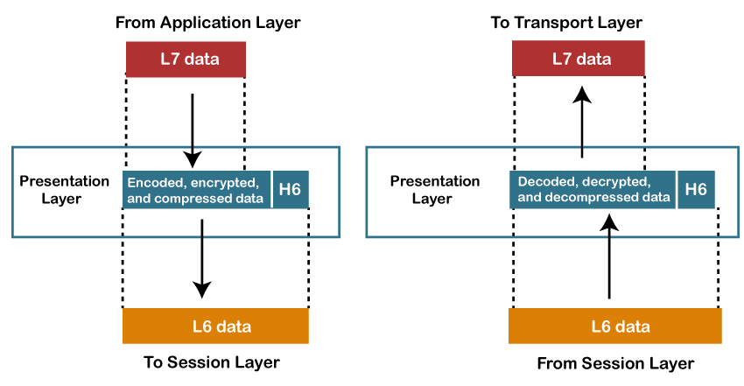

Functions of Presentation layer:

* **Translation:** The processes in two systems exchange the information in the form of character strings, numbers and so on. Different computers use different encoding methods, the presentation layer handles the interoperability between the different encoding methods. It converts the data from sender-dependent format into a common format and changes the common format into receiver-dependent format at the receiving end.
* **Encryption:** Encryption is needed to maintain privacy. Encryption is a process of converting the sender-transmitted information into another form and sends the resulting message over the network.
* **Compression:** Data compression is a process of compressing the data, i.e., it reduces the number of bits to be transmitted. Data compression is very important in multimedia such as text, audio, video.

## 7.Application Layer:

* An application layer serves as a window for users and application processes to access network service.
* It handles issues such as network transparency, resource allocation, etc.
* An application layer is not an application, but it performs the application layer functions.
* This layer provides the network services to the end-users.

## OSI Model

Functions of Application layer:

* **File transfer, access, and management (FTAM):** An application layer allows a user to access the files in a remote computer, to retrieve the files from a computer and to manage the files in a remote computer.
* **Mail services:** An application layer provides the facility for email forwarding and storage.
* Directory services: An application provides the distributed database sources and is used to provide that global information about various objects

## This is the only layer that directly interacts with data from the user. Software applications like web browsers and email clients rely on the application layer to initiate communications.

## But it should be made clear that client software applications are not part of the application layer; rather the application layer is responsible for the protocols and data manipulation that the software relies on to present meaningful data to the user. Application layer protocols include HTTP as well as SMTP (Simple Mail Transfer Protocol is one of the protocols that enables email communications).

## TCP/IP :

* The TCP/IP model was developed prior to the OSI model.
* The TCP/IP model is not exactly similar to the OSI model.
* The TCP/IP model consists of five layers: the application layer, transport layer, network layer, data link layer and physical layer.
* The first four layers provide physical standards, network interface, internetworking, and transport functions that correspond to the first four layers of the OSI model and these four layers are represented in TCP/IP model by a single layer called the application layer.
* TCP/IP is a hierarchical protocol made up of interactive modules, and each of them provides specific functionality.

Here, hierarchical means that each upper-layer protocol is supported by two or more lower-level protocols.

## Functions of TCP/IP layers:

## TCP/IP model

## The Internet Protocol (IP) is the address system of the Internet and has the core function of delivering packets of information from a source device to a target device.

## IP is the primary way in which network connections are made, and it establishes the basis of the Internet. IP does not handle packet ordering or error checking. Such functionality requires another protocol, typically TCP.

## The TCP/IP relationship is similar to sending someone a message written on a puzzle through the mail. The message is written down and the puzzle is broken into pieces.

## Each piece then can travel through a different postal route, some of which take longer than others.

## When the puzzle pieces arrive after traversing their different paths, the pieces may be out of order. The Internet Protocol makes sure the pieces arrive at their destination address. The TCP protocol can be thought of as the puzzle assembler on the other side who puts the pieces together in the right order, asks for missing pieces to be resent, and lets the sender know the puzzle has been received.

## TCP maintains the connection with the sender from before the first puzzle piece is sent to after the final piece is sent. IP is a connectionless protocol, which means that each unit of data is individually addressed and routed from the source device to the target device, and the target does not send an acknowledgement back to the source.

## That’s where protocols such as the Transmission Control Protocol (TCP) come in. TCP is used in conjunction with IP in order to maintain a connection between the sender and the target and to ensure packet order.

## For example, when an email is sent over TCP, a connection is established and a 3-way handshake is made. First, the source sends an SYN “initial request” packet to the target server in order to start the dialogue.

## Then the target server then sends a SYN-ACK packet to agree to the process. Lastly, the source sends an ACK packet to the target to confirm the process, after which the message contents can be sent.

## The email message is ultimately broken down into packets before each packet is sent out into the Internet, where it traverses a series of gateways before arriving at the target device where the group of packets are reassembled by TCP into the original contents of the email.

## Network Access Layer

* A network layer is the lowest layer of the TCP/IP model.
* A network layer is the combination of the Physical layer and Data Link layer defined in the OSI reference model.
* It defines how the data should be sent physically through the network.
* This layer is mainly responsible for the transmission of the data between two devices on the same network.
* The functions carried out by this layer are encapsulating the IP datagram into frames transmitted by the network and mapping of IP addresses into physical addresses.
* The protocols used by this layer are ethernet, token ring, FDDI, X.25, frame relay.

## Internet Layer

* An internet layer is the second layer of the TCP/IP model.
* An internet layer is also known as the network layer.
* The main responsibility of the internet layer is to send the packets from any network, and they arrive at the destination irrespective of the route they take.

### **Following are the protocols used in this layer are:**

**IP Protocol:** IP protocol is used in this layer, and it is the most significant part of the entire TCP/IP suite.

Following are the responsibilities of this protocol:

* **IP Addressing:** This protocol implements logical host addresses known as IP addresses. The IP addresses are used by the internet and higher layers to identify the device and to provide internetwork routing.
* **Host-to-host communication:** It determines the path through which the data is to be transmitted.
* **Data Encapsulation and Formatting:** An IP protocol accepts the data from the transport layer protocol. An IP protocol ensures that the data is sent and received securely, it encapsulates the data into message known as IP datagram.
* **Fragmentation and Reassembly:** The limit imposed on the size of the IP datagram by data link layer protocol is known as Maximum Transmission unit (MTU). If the size of IP datagram is greater than the MTU unit, then the IP protocol splits the datagram into smaller units so that they can travel over the local network. Fragmentation can be done by the sender or intermediate router. At the receiver side, all the fragments are reassembled to form an original message.
* **Routing:** When IP datagram is sent over the same local network such as LAN, MAN, WAN, it is known as direct delivery. When source and destination are on the distant network, then the IP datagram is sent indirectly. This can be accomplished by routing the IP datagram through various devices such as routers.

**ARP Protocol**

Backward Skip 10sPlay VideoForward Skip 10s

* ARP stands for **Address Resolution Protocol**.
* ARP is a network layer protocol which is used to find the physical address from the IP address.
* **The two terms are mainly associated with the ARP Protocol:**
  + **ARP request:** When a sender wants to know the physical address of the device, it broadcasts the ARP request to the network.
  + **ARP reply:** Every device attached to the network will accept the ARP request and process the request, but only recipient recognize the IP address and sends back its physical address in the form of ARP reply. The recipient adds the physical address both to its cache memory and to the datagram header

**ICMP Protocol**

* **ICMP** stands for Internet Control Message Protocol.
* It is a mechanism used by the hosts or routers to send notifications regarding datagram problems back to the sender.
* A datagram travels from router-to-router until it reaches its destination. If a router is unable to route the data because of some unusual conditions such as disabled links, a device is on fire or network congestion, then the ICMP protocol is used to inform the sender that the datagram is undeliverable.
* An ICMP protocol mainly uses two terms:
  + **ICMP Test:** ICMP Test is used to test whether the destination is reachable or not.
  + **ICMP Reply:** ICMP Reply is used to check whether the destination device is responding or not.
* The core responsibility of the ICMP protocol is to report the problems, not correct them. The responsibility of the correction lies with the sender.
* ICMP can send the messages only to the source, but not to the intermediate routers because the IP datagram carries the addresses of the source and destination but not of the router that it is passed to.

## Transport Layer

The transport layer is responsible for the reliability, flow control, and correction of data which is being sent over the network.

The two protocols used in the transport layer are **User Datagram protocol and Transmission control protocol**.

* **User Datagram Protocol (UDP)**
  + It provides connectionless service and end-to-end delivery of transmission.
  + It is an unreliable protocol as it discovers the errors but not specify the error.
  + User Datagram Protocol discovers the error, and ICMP protocol reports the error to the sender that user datagram has been damaged.
  + **UDP consists of the following fields:**  
    **Source port address:** The source port address is the address of the application program that has created the message.  
    **Destination port address:** The destination port address is the address of the application program that receives the message.  
    **Total length:** It defines the total number of bytes of the user datagram in bytes.  
    **Checksum:** The checksum is a 16-bit field used in error detection.
  + UDP does not specify which packet is lost. UDP contains only checksum; it does not contain any ID of a data segment.

## TCP/IP model TCP/IP model

**Transmission Control Protocol (TCP)**

* + It provides a full transport layer services to applications.
  + It creates a virtual circuit between the sender and receiver, and it is active for the duration of the transmission.
  + TCP is a reliable protocol as it detects the error and retransmits the damaged frames. Therefore, it ensures all the segments must be received and acknowledged before the transmission is considered to be completed and a virtual circuit is discarded.
  + At the sending end, TCP divides the whole message into smaller units known as segment, and each segment contains a sequence number which is required for reordering the frames to form an original message.
* **Transmission Control Protocol (TCP)**
  + It provides a full transport layer services to applications.
  + It creates a virtual circuit between the sender and receiver, and it is active for the duration of the transmission.
  + TCP is a reliable protocol as it detects the error and retransmits the damaged frames. Therefore, it ensures all the segments must be received and acknowledged before the transmission is considered to be completed and a virtual circuit is discarded.
  + At the sending end, TCP divides the whole message into smaller units known as segment, and each segment contains a sequence number which is required for reordering the frames to form an original message.
  + At the receiving end, TCP collects all the segments and reorders them based on sequence numbers.
  + At the receiving end, TCP collects all the segments and reorders them based on sequence numbers.

ADVERTISEMENT

## 

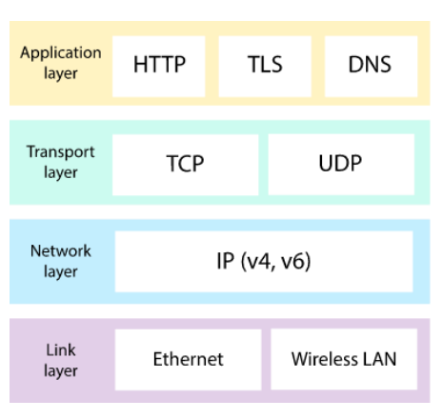

User Datagram Protocol (UDP/IP) :

UDP, is a communication protocol used across the Internet for especially time-sensitive transmissions such as video playback or DNS lookups.

* It speeds up communications by not formally establishing a connection before data is transferred. This allows data to be transferred very quickly, but it can also cause packets to become lost in transit — and create opportunities for exploitation in the form of DDoS attacks. How does UDP work? Like all networking protocols,
* UDP is a standardized method for transferring data between two computers in a network. Compared to other protocols, UDP accomplishes this process in a simple fashion: it sends packets (units of data transmission) directly to a target computer, without establishing a connection first, indicating the order of said packets, or checking whether they arrived as intended. (UDP packets are referred to as ‘datagrams’.) UDP is faster but less reliable than TCP, another common transport protocol. In a TCP communication, the two computers begin by establishing a connection via an automated process called a ‘handshake.’
* Only once this handshake has been completed will one computer actually transfer data packets to the other. UDP communications do not go through this process. Instead, one computer can simply begin sending data to the other.
* 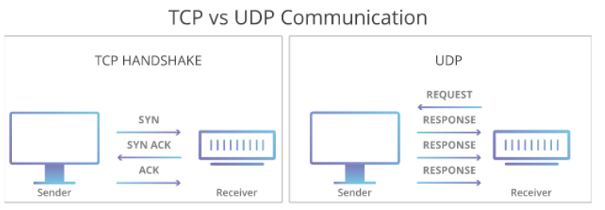
* In addition, TCP communications indicate the order in which data packets should be received and confirm that packets arrive as intended. If a packet does not arrive — e.g. due to congestion in intermediary networks — TCP requires that it be re-sent.
* UDP communications do not include any of this functionality. These differences create some advantages. Because UDP does not require a ‘handshake’ or check whether data arrives properly, it is able to transfer data much faster than TCP. However, this speed creates tradeoffs. If a UDP datagram is lost in transit, it will not be re-sent. As a result, applications that use UDP must be able to tolerate errors, loss, and duplication.
* Technically, such packet loss is less a flaw in UDP than a consequence of how the Internet is built. Most network routers do not perform packet ordering and arrival confirmation by design, because doing so would require an unfeasible amount of additional memory. TCP is a way of filling this gap when an application requires it.
* **User Datagram Protocol (UDP)**
  + It provides connectionless service and end-to-end delivery of transmission.
  + It is an unreliable protocol as it discovers the errors but not specify the error.
  + User Datagram Protocol discovers the error, and ICMP protocol reports the error to the sender that user datagram has been damaged.
  + **UDP consists of the following fields:**  
    **Source port address:** The source port address is the address of the application program that has created the message.  
    **Destination port address:** The destination port address is the address of the application program that receives the message.  
    **Total length:** It defines the total number of bytes of the user datagram in bytes.  
    **Checksum:** The checksum is a 16-bit field used in error detection.
  + UDP does not specify which packet is lost. UDP contains only checksum; it does not contain any ID of a data segment.